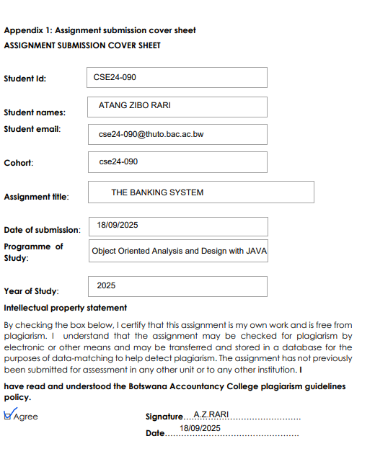

**REQUIREMENTS ELICITATION**

**FUCTIONAL REQUIREMENTS**

Functional requirements are statements that describe the features and services that the users expect of the system. They include

* Login authentication using user credentials
* A user friendly dashboard
* Customer providing identification details
* Login view for both customer and employee
* Supporting of multiple accounts of different types per customer
* Types include savings, chequing and investment accounts
* Savings and investment accounts should be interest bearing accounts of different interest rates
* Providing of withdrawal and deposit transaction for appropriate accounts
* The dashboard should include a balance view for each account for the customer

**NON-FUCTIONAL REQUIREMENTS**

Non-functional are statements that describe the quality aspects of the system as it provides its features services. A form of non-functional requirements is

* SECURITY OF THE BANKING SYSTEM:

done using login screens and passwords to allow only the customer and employees can see their system.

* PERFORMANCE:

The system should have a quick response time of not more than 0.3 seconds for a better customer quality service.

* USABILITY OF THE SYSTEM:

The system should be clean and easy to use for the customer and employee. They should be able to work the application with minimal assistance.

**SYSTEM USE CASE DIAGRAM**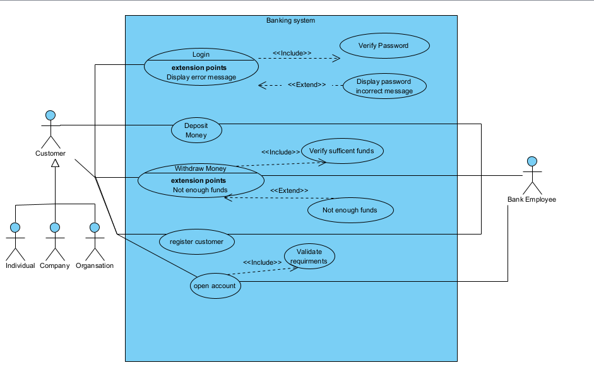

The use case diagram represents the system’s external behaviour. The key actors in this system are the customer and the bank employee that takes care of the customer’s banking needs.

**CLASS DIAGRAM**

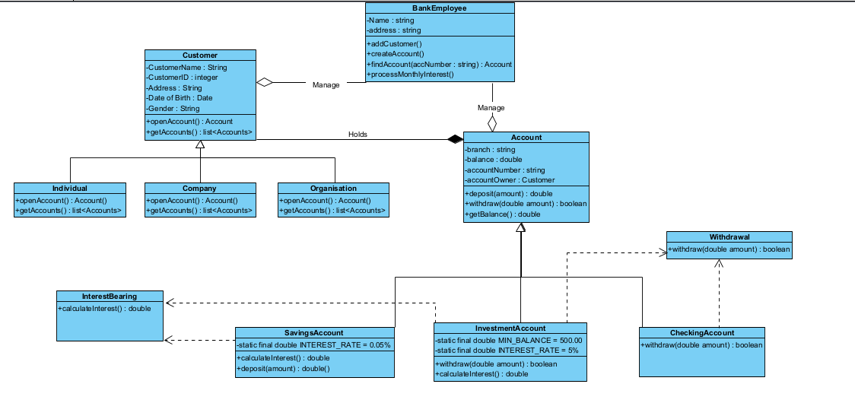

**SEQUENCE DIAGRAM**

**LOGIN SEQUENCE DIAGRAM**

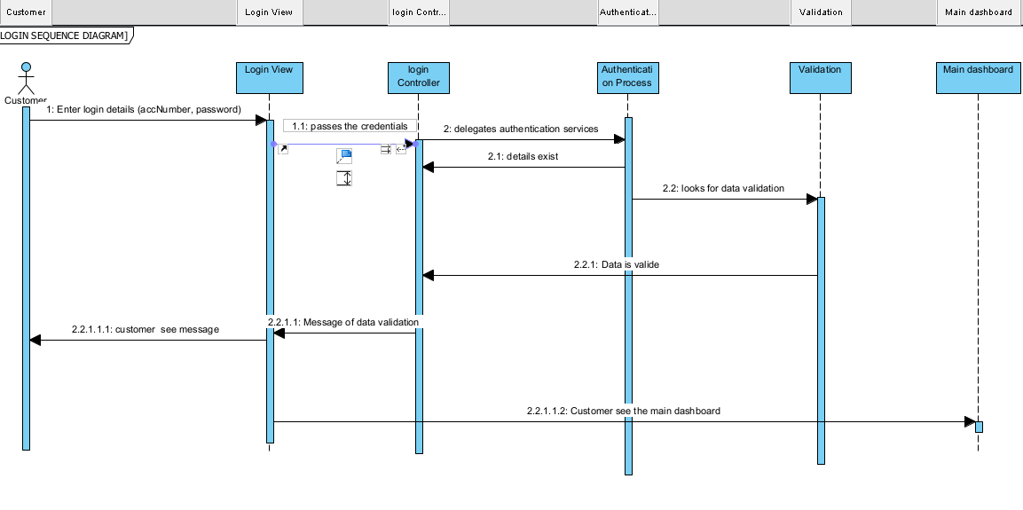

**DEPOSIT SEQUENCE DIAGRAM**

**STATE DIAGRAM**

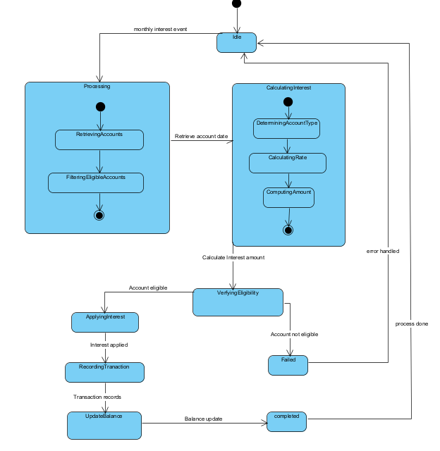

The state machine diagram shows the process of which interest is paid to the respective account and the respective amount.

APPENDIX: INTERVIEW RECORD

**DATE**: SEPTEMBER 17  
**INTERVIEWER**: ATANG Z RARI  
**INTERVIEWEE**: THEMBA MOENG

1. WHAT ARE THE ESSENTIAL FEATURES YOU EXPECT FROM THE BANKING SYSTEM?

Data should be encrypted in the database. The banking system should be secure through login authentication. The system should include a dashboard to make the system intuitive and user friendly. The account details and customer details should be editable, from the database.

Both the customer and the bank employee should login with their credentials to access their unique GUI. The system should allow an employee to manage and view the customers and their accounts.

Ability to pay interest to the accounts that are applicable for the interest, an employee responsible should be able to initiate the activity of applying interest to the respective accounts

1. WHAT PERSONAL DETAILS MUST BE COLLECTED?

ID, Customer Name, Residential address, Date of Birth and gender are customer details that should be collected from a customer or client

1. SHOULD THE SYSTEM SUPPORT CUSTOMER LOGIN/AUTHENTICATION?

Yes, the system should support both customer login and employee login for security purposes.

1. SHOULD THE SYSTEM SUPPORT MULTIPLE ACCOUNTS PER CUSTOMER?

Yes. They may open more than one account as they desire.

1. WHAT TYPES OF ACCOUNTS SHOULD BE SUPPORTED?

A savings account, a cheque account and an investment account are the accounts that should be offered in the banking system.

1. WHAT ARE THE CONDITIONS FOR OPENING EACH ACCOUNT?

A savings account is opened to deposit funds for future use, it will offer a 0.05% interest rate, and the customer cannot withdraw funds.

A cheque account is used to credit salaries so a company name and address should be provided by the customer.

An investment account is one that pays more interest of 5% and can only be opened with an initial deposit of BWP500.00

1. WHAT TYPES OF TRANSACTIONS SHOULD BE ALLOWED?

Withdrawals and deposits are transactions that should occur.

1. SHOULD WE INCLUDE TRANSACTION HISTORY?

Yes, to allow the customer to see the transactions that have occurred

1. SHOULD CUSTOMERS BE ABLE TO VIEW PAST TRANSACTIONS?

Yes.

1. ANY OTHER QUALITY ATTRIBUTES?

A customer should be able to view their balance and other transactions in their accounts